SIMATS ENGINEERING (SAVEETHA SCHOOL OF ENGINEERING)
Department of Computer Science and Engineering
CO1 ASSESSMENT TOOL 2 – Agile Sprint Planning & User Story Workshop

Course Code: | CSA10 / CSA1005 | Course Title: | Software Engineering
CO Assessed: | CO1 | Assessment: | Assessment Tool 2 – Agile Sprint Planning & User Story Workshop
Weightage: | 20% | Total Marks: | 25
CO1 Statement: | Apply advanced methodologies and agile project management techniques to manage software projects effectively
Student Name: | M RENE DANIEL | Reg. No.: | 1971260041
Date: | 20/10/2026 | Duration: | 60 minutes

Code of Conduct
I, M RENE DANIEL (Reg. No. 1971260041), certify that this submission is my original work and that I have adhered to the guidelines specified for this assessment. I understand that any violation of academic integrity rules will result in disciplinary action.
Signature of the Student: _________________________

Annexure A – Agile Sprint Planning & User Story Workshop
  - Define a clear sprint goal and describe the expected sprint deliverables, including the features to be completed at the end of the sprint.
Case Study: Smart Emergency Medicine Availability and Hospital Coordination Platform
Course: Software Engineering | Course Code: CSA10 / CSA1005 | Student: M RENE DANIEL | Register Number: 1971260041
1. Project Vision and Industry Context
During medical emergencies, patients and healthcare providers may need to quickly identify hospitals with required facilities, specialist services, or critical resources. Calling multiple hospitals manually can delay decision-making. A coordinated platform can provide regularly updated information about participating hospitals, departments, emergency services, and critical resources.
Project vision: To provide a reliable and secure digital platform that helps authorized healthcare personnel identify suitable hospitals based on patient requirements and resource availability, submit emergency coordination requests, notify relevant hospital personnel, and maintain coordination records.
Project Objectives
• Maintain participating hospital information.
• Record emergency facilities and emergency services.
• Maintain department and specialist information.
• Track resource availability where supported.
• Receive and manage emergency coordination requests.
• Match requests with suitable healthcare facilities.
• Notify authorized hospital personnel.
• Maintain emergency coordination histories and generate operational reports.
Key Stakeholders
• Patients / patient representatives – provide emergency requirements through authorized personnel or approved channels.
• Emergency healthcare personnel – submit requests and identify suitable facilities for patient needs.
• Hospital administrators – maintain hospital profiles, facilities, and service information.
• Department heads and specialists – maintain relevant department and specialist availability information.
• Platform administrator – manage access permissions, monitor platform activity, and support data quality.
2. Epics and User Stories
• Epic 1 – Hospital Information: As a hospital administrator, I want to maintain hospital details and contact information, so that authorized users can identify participating facilities.
• Epic 2 – Facility and Department Management: As an authorized hospital user, I want to record emergency facilities, departments, and specialists, so that the platform reflects available services.
• Epic 3 – Resource Availability: As an authorized healthcare user, I want to view resource availability where supported, so that I can assess whether a facility may meet patient requirements.
• Epic 4 – Emergency Request Management: As emergency personnel, I want to submit a coordination request with patient requirements, so that suitable facilities can be identified.
• Epic 5 – Facility Matching: As emergency personnel, I want requests to be matched against facility services and availability, so that I can find appropriate hospitals efficiently.
• Epic 6 – Notifications and Communication: As authorized hospital personnel, I want to receive notifications about relevant requests, so that I can respond promptly.
• Epic 7 – Coordination History and Reports: As an authorized administrator, I want to review past coordination requests and operational reports, so that activity can be monitored and improved.
3. Acceptance Criteria (Given–When–Then)
• Hospital information: Given an authorized hospital administrator is logged in, when they submit valid hospital details, then the system saves the information and makes it available to permitted users.
• Facility information: Given an authorized user selects a hospital, when they add or update facilities, departments, and specialist details, then the system records the changes.
• Resource availability: Given a participating hospital maintains resource data, when an authorized user views the facility profile, then the system displays the latest recorded availability and its update status.
• Emergency request: Given authorized personnel enter the patient requirements and required services, when they submit the request, then the system records it with a unique identifier and status.
• Facility matching: Given a request contains required services, when matching is performed, then the system lists facilities whose recorded services meet the requirements and indicates available information.
• Notification: Given a request is matched to a suitable facility, when the request is routed, then authorized hospital personnel receive a notification through the configured communication mechanism.
• History and reports: Given coordination requests have been recorded, when an authorized user requests history or an operational report, then the system displays information permitted by their access role.
4. Prioritized Product Backlog
Priority is based on emergency value and dependencies. Hospital profiles and facility information come first because matching, request routing, and reporting depend on reliable data.
5. Sprint Backlog – Sprint 1
Sprint duration: 2 weeks (proposed). Sprint 1 focuses on the platform foundation by enabling hospital profile management and recording facility, department, and specialist information.
• Task 1: Define hospital account roles and access permissions.
• Task 2: Create basic login and authorized-user access screens.
• Task 3: Design hospital profile fields, including contact details and location.
• Task 4: Build forms to record emergency facilities, departments, and specialists.
• Task 5: Display saved hospital and facility information in a dashboard.
• Task 6: Test access control, required-field validation, and saving/displaying hospital information.
6. Story Point Estimation and Justification
Estimation approach: Relative estimation using a Fibonacci-style scale (1, 2, 3, 5, 8). The values reflect relative effort, complexity, and uncertainty; they are planning estimates rather than hours.
• Login and role-based access – 3 points: a familiar workflow with basic permission checks.
• Hospital profile management – 5 points: requires structured fields, validation, and data storage.
• Facility and department information – 5 points: multiple related service and specialist details must be maintained.
• Resource availability display – 5 points: depends on supported resource data and update status.
• Emergency request matching and routing – 8 points: involves patient requirements, facility criteria, request status, and coordination.
7. Sprint Goal and Expected Deliverables
Sprint goal: Enable authorized users to access the platform and allow participating hospitals to publish their profiles, emergency facilities, departments, and specialist information.
Expected deliverables at the end of Sprint 1:
• Basic login and role-based access for authorized hospital users.
• Hospital profile form with required-field validation.
• Facility, department, and specialist information forms and dashboard display.
• Basic test cases and recorded results for access control and hospital information functions.
• A short demonstration of the working Sprint 1 features.
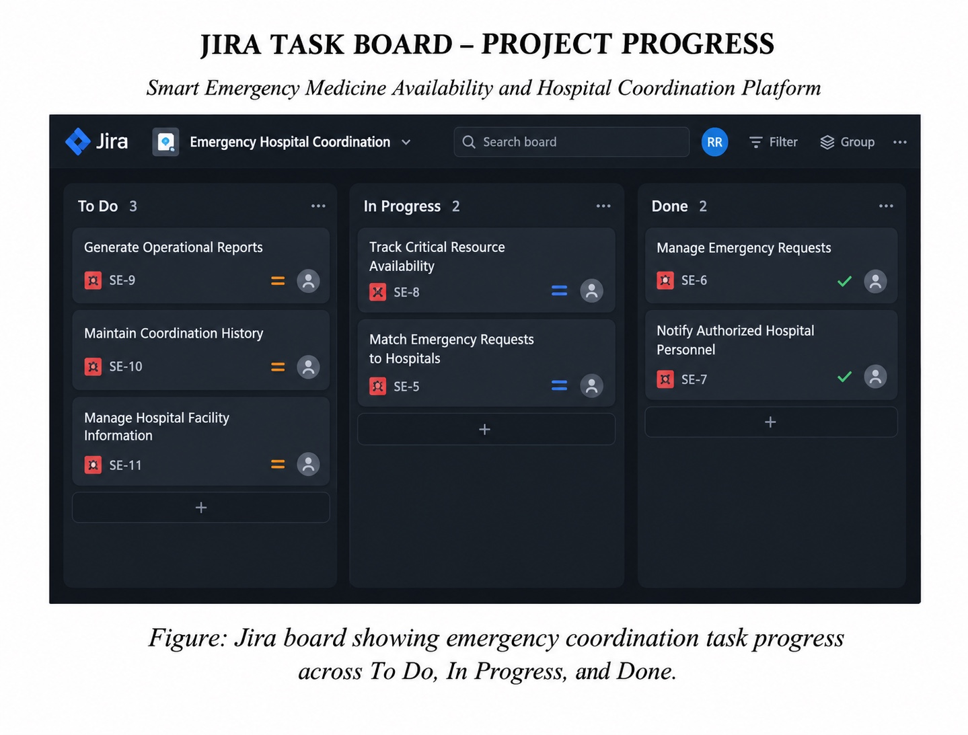
Conclusion
The Agile plan delivers the platform incrementally, starting with secure access and hospital information before adding resource availability, emergency requests, facility matching, notifications, coordination history, and reports. Prioritizing reliable facility data and access controls provides a practical foundation for faster inter-hospital coordination while protecting sensitive information.
Rubrics for Calculation
Criteria | Excellent (5 Marks) | Good (3 Marks) | Satisfactory (2 Marks) | Needs Improvement (1 Mark)
Project Vision & Stakeholder Identification (30%) | Project vision is clear, comprehensive, and aligned with the problem statement. All relevant stakeholders and their roles are correctly identified. | Vision is clear with minor omissions. Most stakeholders are correctly identified. | Vision is partially defined. Some stakeholders are missing or incorrectly identified. | Vision is unclear or incomplete. Stakeholders are poorly identified or missing.
Epics & User Stories (25%) | Epics are well-defined and user stories are complete, follow Agile format, and fully capture functional requirements. | Epics and user stories are mostly complete with minor formatting or requirement issues. | User stories are partially complete with limited Agile structure. | User stories are incomplete, unclear, or do not follow Agile practices.
Acceptance Criteria (20%) | Acceptance criteria are specific, measurable, testable, and aligned with all user stories. | Acceptance criteria are mostly clear and testable with minor gaps. | Acceptance criteria are partially defined and lack clarity or completeness. | Acceptance criteria are missing or not aligned with user stories.
Product Backlog Prioritization & Sprint Planning (15%) | Product backlog is logically prioritized, sprint backlog is realistic, and task breakdown is complete. | Backlog prioritization and sprint planning are mostly appropriate with minor issues. | Prioritization or sprint planning is partially complete with limited justification. | Backlog prioritization and sprint planning are poorly organized or incomplete.
Story Point Estimation, Sprint Goal & Presentation (10%) | Story point estimation is well justified, sprint goal is clear, deliverables are realistic, and presentation is professional and well organized. | Estimation and sprint goal are mostly appropriate with minor inconsistencies. Presentation is clear. | Estimation or sprint goal lacks justification. Presentation is adequate but incomplete. | Estimation is unrealistic or missing. Sprint goal, deliverables, and presentation are unclear or incomplete.

Criteria | Mark
Project Vision & Stakeholder Identification (30%) | /5
Epics & User Stories (25%) | /5
Acceptance Criteria (20%) | /5
Product Backlog Prioritization & Sprint Planning (15%) | /5
Story Point Estimation, Sprint Goal & Presentation (10%) | /5
TOTAL | /25

Priority | Backlog item | User value / dependency | Story points
P1 | Hospital registration / login and access control | Required to restrict platform access to authorized users | 3
P2 | Create and view hospital profiles | Core facility information needed for coordination | 5
P3 | Manage facilities, departments, and specialists | Provides service information for matching requests | 5
P4 | Record and display resource availability | Supports assessment of current facility capability where data is maintained | 5
P5 | Submit and manage emergency requests | Core emergency coordination workflow | 5
P6 | Match requests to suitable facilities | Depends on request requirements and hospital service data | 8
P7 | Notify authorized hospital personnel | Enables timely response to matched requests | 5
P8 | Coordination history and operational reports | Supports monitoring, audit, and service improvement | 5

JIRA TASK BOARD – PROJECT PROGRESS
Smart Emergency Medicine Availability and Hospital Coordination Platform
Figure: Jira board showing task progress across To Do, In Progress, and Done.

